Interconnecting Devices in Computer Networks
Theory
In computer networks, various devices play a crucial role in ensuring smooth communication and data transfer. Below is a list of key interconnecting devices along with their functions:
1. Router
- Function: Routes data between different networks by determining the best path for data packets.
- Usage: Used in homes, offices, and large networks to connect to the internet and different subnets.
- Example: Wi-Fi routers used for internet connectivity.
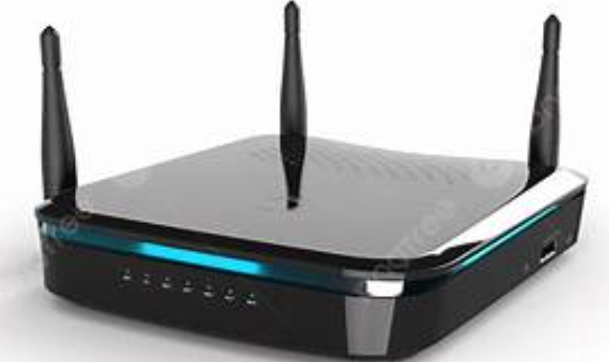
2. Modem (Modulator-Demodulator)
1- Function: Converts digital signals from a computer into analog signals for transmission over telephone lines and vice versa.
2- Usage: Used to connect computers to the internet via ISPs.
- Example: DSL and cable modems.
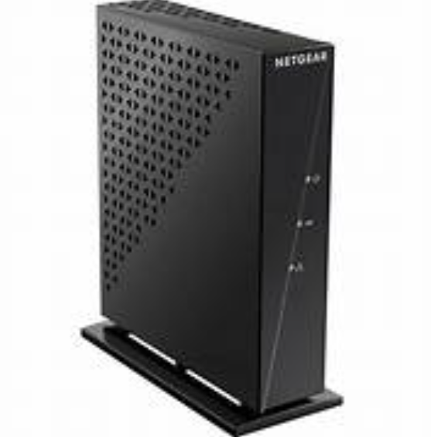
3. Switch
- Function: Connects multiple devices within a LAN and uses MAC addresses to forward data to the correct destination.
- Usage: Used in enterprise networks for efficient data transfer.
- Example: Ethernet switches used in office networks.
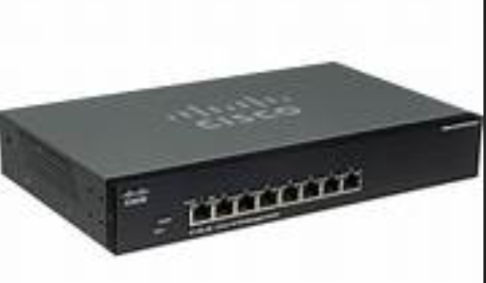
4. Hub
- Function: A basic networking device that transmits data packets to all devices in a network.
- Usage: Used in small networks where efficiency is not a primary concern.
- Example: A passive hub connecting multiple computers.
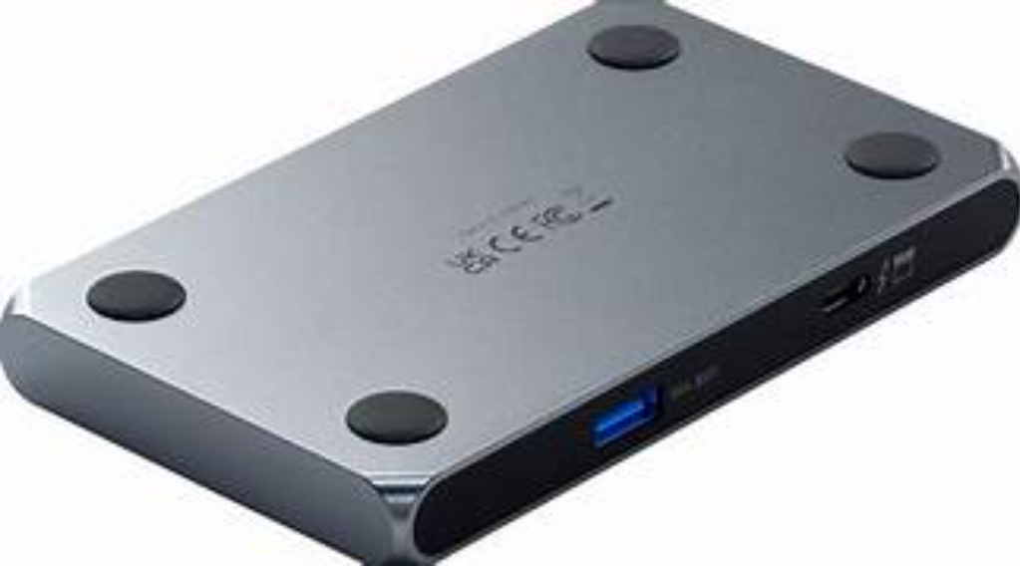
5. Bridge
- Function: Connects two or more network segments and filters traffic based on MAC addresses.
- Usage: Used to divide large networks and reduce traffic congestion.
- Example: A bridge connecting two LANs.
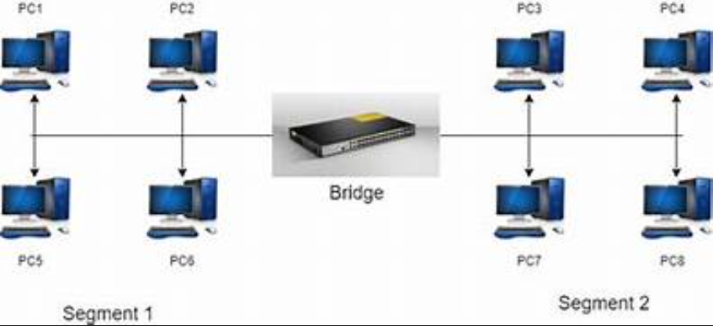
6. Gateway
- Function: Acts as a translator between different network protocols.
- Usage: Used in enterprises to connect networks with different communication protocols.
- Example: A VoIP gateway converting voice data to digital signals.
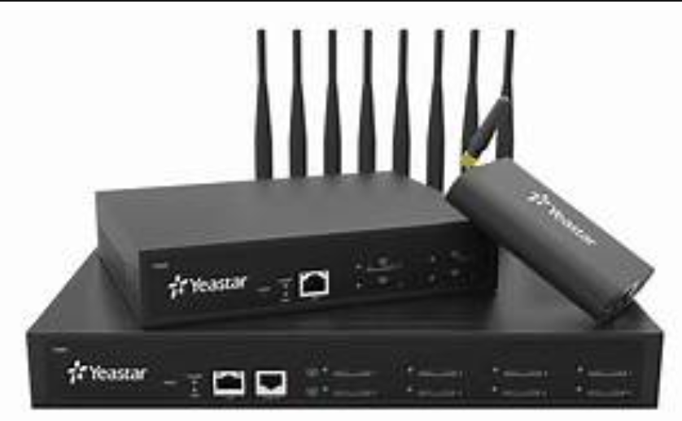
7. Repeater
- Function: Amplifies and retransmits signals to extend the range of a network.
- Usage: Used in large networks to prevent signal loss over long distances.
- Example: Wi-Fi repeaters boosting wireless signals.
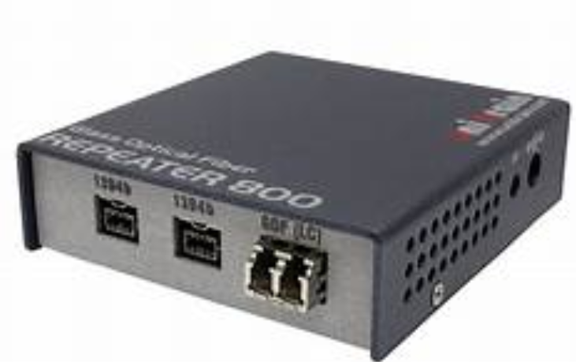

CONCLUSION
These devices form the backbone of networking, ensuring efficient data transfer and connectivity in various environments.

